AI-Based Smart Attendance System Using Face Recognition with OpenCV and Django Framework

A PROJECT REPORT

Submitted by

MOHAMMAD SAHIL (220171601062)
MOHAMMED ASIF (220171601065)

Under the guidance of
Dr.C.VIJAYALAKSHMI

in partial fulfillment for the award of the degree of

BACHELOR OF TECHNOLOGY
in
ARTIFICIAL INTELLIGENCE AND DATA SCIENCE


APRIL 2026



BONAFIDE CERTIFICATE

Certified that this project report “AI-Based Smart Attendance System Using Face Recognition with OpenCV and Django Framework” is the bonafide work of MOHAMMED ASIF (220171601065) and MOHAMMAD SAHIL (220171601062) who carried out the project work under my supervision. Certified further, that to the best of our knowledge, the work reported herein does not form part of any other project report or dissertation on the basis of which a degree or award was conferred on an earlier occasion on this or any other candidate.

SIGNATURE
Dr.C.VIJAYALAKSHMI
Supervisor
Assistant Professor (Sr. Gr.)
Department of CSE
B S Abdur Rahman Crescent Institute of Science and Technology Vandalur, Chennai-600048.
SIGNATURE
Dr. W. AISHA BANU
Head of the Department
Professor
Department of CSE
B.S. Abdur Rahman. Crescent Institute of Science & Technology Vandalur, Chennai – 600048



VIVA VOICE EXAMINATION

The viva voce examination of the CSD 4251 - project work titled “AI-Based Smart Attendance System Using Face Recognition with OpenCV and Django Framework”, submitted by MOHAMMED ASIF (220171601065) and MOHAMMED SAHIL (220171601062) is held on _______________________.

INTERNAL EXAMINER EXTERNAL EXAMINER

ACKNOWLEDGEMENT
We sincerely express our heartfelt gratitude to Prof. DR. A. PEER MOHAMED, Vice chancellor and Dr. N. THAJUDDIN, Pro-Vice Chancellor, B.S. Abdur Rahman Crescent Institute of Science and Technology, for providing us an environment to carry out our course successfully.
We sincerely thank Dr. N. RAJA HUSSIAN, Registrar for furnishing every essential facility for doing our project.
We thank Dr. SHARMILA SANKAR, Dean, School of Computer, Information and Mathematical Sciences for her motivation and support.
We thank Dr. AISHA BANU W, Professor and Head, Department of Computer Science and Engineering, for providing strong oversight of vision, strategic direction and valuable suggestions.
We express our sincere thanks to the Project Review Committee members, from the Department of Computer Science and Engineering, DR. V. MUTHUPRIYA, Associate Professor and DR. MADHINA BANU, Associate Professor for their valuable suggestions and support.
We obliged our project supervisor Dr. C.VIJAYALAKSHMI, Assistant Professor (Sr. Gr) , (Department of Computer Science and Engineering for her professional guidance and continued assistance during our project.
We thank our class advisor and project coordinator, Dr. R. AKILA, Associate Professor Department of Computer Science and Engineering for her guidance and encouragement throughout our project.
We thank all the Faculty members and the System staff of the Department of Computer Science and Engineering for their valuable support and assistance at various stages of project development.

MOHAMMED SAHIL
MOHAMMED ASIF

ABSTRACT
This research presents an intelligent and automated attendance management system using face recognition techniques integrated with computer vision and web-based technologies. The proposed system utilizes real-time image acquisition through a webcam, followed by preprocessing, face detection, and recognition to accurately identify individuals. The Haar Cascade algorithm is employed for efficient face detection, while the Local Binary Pattern Histogram (LBPH) method is used for robust facial recognition.
Captured facial data is processed through normalization, grayscale conversion, and noise reduction to enhance feature extraction and improve recognition performance under varying environmental conditions. The system automatically records attendance with timestamps in a centralized database, ensuring accuracy and eliminating manual intervention.
A web-based interface developed using the Django framework enables user authentication, attendance monitoring, report generation, and administrative control. Additional modules such as email notifications and event management enhance system functionality and usability. Experimental results demonstrate high accuracy, low latency, and reliable performance in real-time scenarios. The proposed system offers a secure, contactless, and scalable solution for attendance management, suitable for deployment in educational and organizational environments.

TABLE OF CONTENTS
CHAPTER NO. | TITLE | PAGE NO.
 | ABSTRACT | v
 | TABLE OF CONTENTS | iii
 | LIST OF FIGURES | vii
 | LIST OF TABLES | viii
1 | INTRODUCTION | 1
1.1 | OVERVIEW | 1
1.2 | DESCRIPTION | 2
1.3 | OBJECTIVE | 4
1.4 | ABOUT THE PROJECT | 4
1.5 | ORGANIZATION OF THE PROJECT | 7
1.6 | MOTIVATION | 7
1.7 | SCOPE OF THE PROJECT | 10
2 | LITERATURE SURVEY | 11
3 | SYSTEM REQUIREMENTS AND DESIGN | 16
3.1 | PROBLEM DEFINITION | 16
3.2 | EXISTING SYSTEM | 16
3.2.1 | Key limitations of the existing system | 17
3.3 | PROPOSED SYSTEM | 18
3.4 | MODULE IDENTIFICATION | 19
3.4.1 | Image Acquisition & Preprocessing Module | 19
3.4.2 | Face detection module | 19
3.4.3 | Face Recognition Module | 20
3.4.4 | Attendance Management odule | 20
3.4.5 | Application Interface & Query Management | 20
3.5 | SYSTEM ARCHITECTURE | 20
3.6 | SYSTEM REQUIREMENTS | 23
3.7 | TOOLS AND LIBRARIES USED | 24
3.8 | DESIGN PRINCIPLES | 25
3.9 | ALGORITHM | 27
3.9.1 | Algorithm Descriptions | 27
4 | SYSTEM METHODOLOGIES | 28
4.1 | MODULE EXPLANATIONS | 29
4.1.1 | Image Acquisition & Preprocessing Module | 29
4.1.2 | Feature Extraction & Dataset Storage Module | 30
4.1.3 | Semantic Retrieval Module | 30
4.1.4 | Face Recognition & Validation Module | 31
4.1.5 | Application Interface & Attendance Management Module | 32
4.2 | RECOGNITION STRATEGY AND DATA HANDLING | 32
4.3 | DATA MANAGEMENT AND SYSTEM CONTINUITY | 33
5 | IMPLEMENTATION | 35
5.1 | DATA COLLECTION AND PREPROCESSING IMPLEMENTATION | 35
5.2 | MODEL TRAINING AND EVALUATION IMPLEMENTATION | 35
5.3 | SYSTEM WORKFLOW | 37
5.4 | RESULT ANALYSIS | 39
5.4.1 | Evaluation Methodology | 39
5.4.2 | Performance Improvements | 40
5.5 | USE CASES | 41
5.6 | SCALABILITY AND DEPLOYMENT ARCHITECTURE | 44
5.7 | ATTENDANCE ANALYTICS AND REPORT MODULE - DETAILED IMPLEMENTATION | 45
5.8 | ATTENDANCE DASHBOARD | 46
5.9 | LIMITATIONS OF THE CURRENT SYSTEM | 47
5.10 | INTERFACE DESIGN AND USER EXPERIENCE | 48
5.11 | ETHICAL CONSIDERATIONS IN FACE RECOGNITION-BASED ATTENDANCE SYSTEM | 49
5.12 | CHALLENGES ENCOUNTERED DURING DEVELOPMENT | 50
5.13 | SYSTEM BEHAVIOR UNDER EXTENDED USAGE CONDITIONS | 52
6 | CONCLUSION AND FUTURE ENHANCEMENT | 55
6.1 | CONCLUSION | 55
6.2 | FUTURE ENHANCEMENTS | 56
 | REFERENCES | 58
 | APPENDIX | 62
 | APPENDIX A1- INTRODUCTION TO SOURCE CODE | 65
 | APPENDIX A2 – SCREENSHOTS  TECHNICAL BIOGRAPHY | 67  72
LIST OF FIGURES
FIGURE NO. | FIGURE DESCRIPTION | PAGE.NO
3.1 | System Architecture Diagram | 22
5.1 | Workflow diagram | 38
5.3 | Use case diagram | 43
8.1 | Home Page Of The System | 68
8.2 | Attendance Marking Interface | 68
8.3 | Attendance Records Dashboard | 69
8.4 | Upload Marksheet Response | 69
8.5 | Event Management Interface | 70
8.6  8.7 | Absent Notification Email  OD Requests Management Interface | 70  71
LIST OF TABLES
TABLE NO. | TITLE | PAGE.NO
3.1 | Hardware Requirements | 23
3.2 | Software Requirements | 24

CHAPTER 1
INTRODUCTION
  - OVERVIEW
The advancement of digital technologies and the increasing demand for automation in organizational processes have led to the development of intelligent systems capable of improving efficiency and accuracy. One such critical area is attendance management, which plays a vital role in monitoring participation, maintaining records, and ensuring accountability in educational institutions and workplaces. Traditional attendance systems, including manual registers and roll-call methods, have been widely used for decades. However, these approaches are often inefficient, time-consuming, and prone to various forms of manipulation such as proxy attendance and inaccurate data recording.
With the rapid growth of artificial intelligence and computer vision technologies, there has been a significant shift towards automated and contactless systems. Face recognition has emerged as one of the most reliable biometric techniques due to its non-intrusive nature and ability to identify individuals based on unique facial features. Unlike traditional biometric systems such as fingerprint or RFID-based attendance systems, face recognition does not require physical contact or additional hardware tokens, making it more convenient and hygienic, especially in environments with a large number of users.
The proposed smart attendance system utilizes face recognition technology to automate the entire attendance marking process. The system captures real-time images using a camera, processes them using image processing techniques, and identifies individuals by comparing their facial features with a pre-trained dataset. Once a match is found, the system automatically records attendance along with the date and time in a centralized database. This eliminates the need for manual intervention and significantly reduces the chances of errors and fraudulent activities.
In addition to the core functionality of face recognition, the system integrates a web-based platform developed using modern frameworks. This platform allows administrators to manage user data, view attendance records, generate reports, and monitor system performance in real time. The inclusion of additional features such as email notifications, event management, and marksheet uploads enhances the overall utility of the system and makes it a comprehensive solution for institutional management.
The system is designed to be scalable and adaptable to different environments, including schools, colleges, offices, and training centers. It aims to provide a seamless user experience while maintaining high levels of accuracy and performance. By leveraging widely available technologies such as OpenCV and Python, the system ensures cost-effectiveness and ease of implementation. Overall, the proposed system represents a modern approach to attendance management, combining automation, intelligence, and usability in a single framework.
1.2 DESCRIPTION
The proposed face recognition-based attendance system is a comprehensive solution designed to automate the process of recording and managing attendance using computer vision and web technologies. The system operates through a sequence of interconnected modules, each responsible for a specific function within the overall workflow. These modules include image acquisition, preprocessing, face detection, feature extraction, face recognition, attendance recording, and web-based management.
The process begins with the image acquisition module, where real-time video frames are captured using a webcam or camera device. These frames serve as the input for further processing. Since raw images may contain noise, lighting variations, and unnecessary background information, they are passed through a preprocessing stage. In this stage, the images are converted into grayscale format to reduce computational complexity, and normalization techniques are applied to ensure consistency in pixel intensity values. Noise reduction filters may also be used to enhance image clarity.
Following preprocessing, the system performs face detection using the Haar Cascade classifier. This algorithm scans the input image to identify regions that contain human faces. Once a face is detected, the region of interest (ROI) is extracted and passed to the feature extraction module. Accurate face detection is crucial, as it directly affects the performance of the recognition process.
In the feature extraction stage, the Local Binary Pattern Histogram (LBPH) algorithm is used to analyse the facial image. LBPH works by examining the local texture patterns of the face and converting them into numerical representations known as feature vectors. These feature vectors capture the essential characteristics of an individual’s face and are used for comparison during the recognition process.
The face recognition module compares the extracted feature vector with those stored in the database during the training phase. A similarity score, often referred to as a confidence value, is calculated to determine whether the detected face matches any known individual. If the confidence level exceeds a predefined threshold, the system identifies the person and retrieves their corresponding details. If no match is found, the individual is marked as unknown.
Once the identity is confirmed, the attendance recording module automatically logs the individual’s presence along with the current date and time. The system is designed to prevent duplicate entries within a single session, ensuring data accuracy and consistency. All attendance records are stored in a centralized database, which can be accessed and managed through the web interface.
The web-based interface, developed using the Django framework, serves as the control centre of the system. It provides functionalities such as user registration, attendance monitoring, report generation, and administrative control. Users can view attendance data in real time, filter records based on various parameters, and export reports as needed. Additional features such as email notifications can be configured to alert users or administrators about attendance status.
Overall, the system integrates multiple technologies to deliver a seamless and efficient attendance management solution. Its modular design allows for easy maintenance and future enhancements, making it suitable for deployment in various real-world scenarios.

1.3 OBJECTIVE
The main objective of the Face Recognition Attendance System is to develop an automated, accurate, and contactless solution for efficient attendance management.

Specific objectives include:
• To design a system that captures and processes real-time facial images using a camera
• To implement face detection using Haar Cascade for accurate identification of facial regions
• To develop a face recognition module using the LBPH algorithm for reliable user identification
• To automate attendance marking with date and time logging in a centralized database
• To prevent proxy attendance and minimize manual errors
• To provide a user-friendly web interface for attendance monitoring and management
• To enable report generation and real-time attendance tracking
1.4 ABOUT THE PROJECT
The Face Recognition Attendance System is an intelligent and automated solution designed to streamline the process of attendance management using computer vision and machine learning techniques. The system aims to replace traditional attendance methods with a more efficient, accurate, and contactless approach. It integrates image acquisition, facial recognition, database management, and web-based interaction into a unified framework that ensures seamless operation and user convenience.
The system utilizes camera-based input to capture real-time facial images of individuals and processes them using advanced image processing techniques. These images are analyzed using algorithms such as Haar Cascade for face detection and Local Binary Pattern Histogram (LBPH) for face recognition. The extracted facial features are compared with a pre-trained dataset to accurately identify individuals. Once a match is confirmed, the system automatically records attendance along with the corresponding date and time in a centralized database.
The system ensures that attendance marking is accurate, secure, and free from manual intervention. By eliminating the need for physical interaction, such as fingerprint scanning or card swiping, the system provides a hygienic and user-friendly alternative. It also significantly reduces the possibility of proxy attendance, as each individual is identified based on unique facial characteristics. This makes the system highly reliable for use in environments where authenticity and accountability are essential.
The Face Recognition Attendance System is designed to handle different real-world conditions, including variations in lighting, facial expressions, and minor occlusions. Through preprocessing techniques such as grayscale conversion, normalization, and noise reduction, the system enhances image quality to ensure consistent recognition performance. This adaptability allows the system to function effectively in diverse environments such as classrooms, offices, and training centers.
In addition to attendance marking, the system includes a comprehensive web-based interface developed using modern frameworks. This interface allows administrators to manage user data, monitor attendance records, and generate reports in real time. Users can view attendance logs, filter records based on specific criteria, and export data for further analysis. The inclusion of features such as email notifications and event management enhances the functionality of the system and provides a complete attendance management solution.
The system also emphasizes user interaction and accessibility. The interface is designed to be intuitive and easy to use, ensuring that users with minimal technical knowledge can operate the system efficiently. The real-time feedback provided by the system, such as successful recognition messages and attendance confirmation, enhances user confidence and improves the overall experience. This interactive nature makes the system more engaging compared to traditional attendance methods.
Furthermore, the system is built with a modular architecture, allowing different components to function independently while maintaining overall integration. Modules such as face detection, recognition, database management, and user interface can be updated or improved without affecting the entire system. For instance, if a more advanced recognition algorithm becomes available in the future, it can be integrated into the system without requiring a complete redesign. This modularity ensures that the system remains adaptable to technological advancements.
The system is also capable of supporting diverse organizational requirements. Different institutions may have varying attendance policies, reporting formats, and user management needs. The flexibility of the system allows it to be customized according to specific requirements, making it suitable for a wide range of applications. Whether used in educational institutions or corporate environments, the system can be configured to meet different operational needs.
Another important aspect of the system is its focus on efficiency and scalability. The system is designed to handle multiple users and large datasets without significant performance degradation. As the number of users increases, the system can scale accordingly by optimizing database operations and processing techniques. This ensures that the system remains effective even in large-scale deployments.
The Face Recognition Attendance System also contributes to improved organizational productivity. By automating attendance tracking, it reduces the administrative workload associated with manual record keeping. This allows staff and administrators to focus on more important tasks, thereby improving overall efficiency. The availability of accurate and real-time attendance data also supports better decision-making and performance analysis.
In addition, the system promotes transparency and accountability. Since attendance records are generated automatically and stored securely, the chances of manipulation or data loss are minimized. Users can access their attendance records at any time, ensuring clarity and trust in the system. This transparency is particularly beneficial in educational institutions where attendance plays a crucial role in academic evaluation.
The system is designed with future expansion in mind. It provides a foundation for incorporating advanced features such as deep learning-based recognition, cloud integration, and mobile application support. These enhancements can further improve system performance, accessibility, and scalability. By adopting a forward-looking approach, the system ensures long-term relevance and usability.
Overall, the Face Recognition Attendance System represents a modern and intelligent approach to attendance management. By combining automation, accuracy, and user-friendly design, it provides a comprehensive solution that addresses the limitations of traditional methods. Its adaptability, scalability, and efficiency make it a valuable tool for institutions seeking to modernize their attendance tracking processes.
1.5 ORGANIZATION OF THE PROJECT
Chapter 1 - Introduces the project by providing an overall understanding of the face recognition-based attendance system, including its purpose, scope, and significance. It presents the background of traditional attendance methods, highlights their limitations, and explains the need for an automated and contactless solution. The chapter also outlines the objectives of the proposed system along with a brief description of its structure and key components.
Chapter 2 - Presents a detailed review of existing research related to face recognition systems, biometric attendance methods, and computer vision techniques. It discusses various approaches such as fingerprint-based systems, RFID-based attendance, and deep learning-based face recognition models. The chapter analyzes their advantages and limitations, helping to establish the foundation for the proposed system by identifying gaps in existing solutions.
Chapter 3 - Focuses on system requirements and design by clearly defining the problem and analyzing the shortcomings of traditional and existing automated attendance systems. It explains the proposed system architecture in detail and identifies the major modules, including image acquisition, preprocessing, face detection, face recognition, database management, and web interface.
Chapter 4 - Explains the methodologies used in the project by describing how each module functions internally. It covers the complete working process of the system, including image preprocessing, face detection using Haar Cascade, feature extraction using LBPH, and attendance recording. The chapter also explains the algorithms involved and how they contribute to accurate and efficient system performance.
Chapter 5 - Describes the implementation of the system, detailing how the design is translated into a working model. It includes the system workflow, execution process, and integration of different modules using technologies such as Python, OpenCV, and Django. The chapter also presents the results and analysis, providing insights into the performance, accuracy, and effectiveness of the system in real-time scenarios.
Chapter 6 - Concludes the project by summarizing the overall outcomes and key contributions of the face recognition attendance system. It highlights the advantages of the proposed solution over traditional methods and discusses its practical applications. The chapter also outlines possible future enhancements, such as deep learning integration, cloud deployment, and mobile application support, to further improve the system’s functionality and scalability.
1.6 MOTIVATION
The primary motivation behind developing the Face Recognition Attendance System arises from the practical challenges observed in traditional attendance management methods used in educational institutions and workplaces. In many real-world scenarios, attendance is still recorded manually through registers or verbally during roll calls. This process is not only time-consuming but also highly inefficient, especially in environments where the number of individuals is large. Faculty members or administrators often spend a significant portion of valuable time simply marking attendance, which could otherwise be utilized for more productive activities such as teaching or management.
Another major concern that motivated the development of this system is the issue of proxy attendance. In conventional systems, it is relatively easy for individuals to mark attendance on behalf of others, leading to inaccurate records and a lack of accountability. Even in some automated systems like RFID or card-based attendance, misuse is still possible, as cards can be exchanged among users. This lack of authenticity undermines the purpose of attendance tracking and creates challenges in maintaining discipline and transparency.
The need for a contactless and hygienic solution also played a significant role in motivating this project. Traditional biometric systems such as fingerprint scanners require physical contact, which raises concerns related to hygiene, especially in environments where multiple users interact with the same device. This became even more relevant in recent times, where minimizing physical contact has become a priority. Face recognition technology provides a completely contactless alternative, making it a safer and more convenient option.
Another motivating factor is the advancement of computer vision and artificial intelligence technologies, which have made it possible to develop efficient and affordable face recognition systems. With the availability of open-source libraries such as OpenCV and powerful programming languages like Python, implementing real-time face recognition has become more accessible. This creates an opportunity to design a system that is both cost-effective and scalable, without the need for expensive hardware or complex infrastructure.
In addition to technical motivations, there is also a strong need to improve the overall efficiency and reliability of attendance management. Manual systems are prone to human errors such as incorrect entries, missed records, and data mismanagement. These issues can lead to discrepancies in attendance reports, affecting evaluations and decision-making processes. An automated system eliminates these errors by ensuring that attendance is recorded accurately and stored securely in a centralized database.
The motivation also extends to enhancing user convenience and accessibility. Administrators often face difficulties in maintaining and analyzing attendance records over long periods. A web-based system that allows real-time monitoring, report generation, and easy data retrieval can significantly simplify these tasks. By integrating attendance management with a user-friendly interface, the system aims to provide a seamless experience for both administrators and users.
Furthermore, the project is driven by the goal of creating a scalable solution that can be adapted to different environments. Whether it is a classroom, office, or training center, the system should be flexible enough to handle varying numbers of users and operational requirements. This adaptability ensures that the system remains relevant across different use cases and can be expanded as needed.
Finally, the motivation behind this project is to leverage modern technology to solve a real-world problem in a practical and impactful way. By combining automation, accuracy, and ease of use, the Face Recognition Attendance System aims to bridge the gap between traditional attendance methods and modern digital solutions. It reflects the broader vision of using technology to improve efficiency, enhance security, and simplify everyday processes in institutional and organizational settings.

1.7 SCOPE OF THE PROJECT
The scope of the Face Recognition Attendance System covers the design, development, and evaluation of an automated attendance management solution using computer vision techniques. The system is intended to be used in educational institutions and workplaces as a contactless and efficient alternative to traditional attendance methods.
The system processes real-time facial images captured through a camera and performs face detection and recognition using Haar Cascade and LBPH algorithms. It includes image preprocessing, feature extraction, and identity matching as part of the recognition pipeline. The system maintains a dataset of registered users and records attendance automatically with timestamps in a centralized database.
The scope also includes a web-based interface that allows administrators to manage user data, view attendance records, and generate reports. The system is evaluated based on metrics such as recognition accuracy, precision, and response time under different environmental conditions.

CHAPTER 2
LITERATURE SURVEY
Bugingo et al. [1] explored the enhancement of face recognition attendance systems by incorporating real-time face tracking mechanisms. Their study demonstrated that continuous tracking of facial movements improves recognition accuracy by maintaining focus on the subject even during motion. This approach reduces errors caused by sudden movements or partial occlusions, which are common in real-time environments such as classrooms. The research also highlighted that integrating tracking with recognition leads to more stable and reliable attendance logging. However, the system still faced challenges in handling crowded environments where multiple faces overlap within the camera frame.
Patel et al. [2] developed a real-time student attendance system using artificial intelligence techniques for face recognition. Their work focused on improving automation in attendance management by eliminating manual processes and reducing human error. The system used machine learning models to detect and recognize faces efficiently, achieving high accuracy in controlled environments. The study emphasized the importance of dataset quality and preprocessing in achieving reliable results. Despite its effectiveness, the system showed limitations under varying lighting conditions and required further optimization for scalability.
Ray [3] proposed a face recognition-based attendance system integrated with geolocation and real-time action logging. This system not only identified individuals but also recorded their geographical location during attendance marking, adding an additional layer of verification. The inclusion of real-time logging improved transparency and accountability, making the system suitable for remote or distributed environments. However, the reliance on location data introduced concerns related to privacy and increased system complexity.
Durga et al. [4] investigated face detection and recognition systems specifically designed for student attendance applications. Their study focused on combining detection and recognition techniques to create a seamless attendance workflow. The system demonstrated improved efficiency compared to traditional methods and reduced the chances of proxy attendance. However, the authors noted that variations in facial expressions and environmental conditions could affect recognition performance, indicating the need for more robust algorithms.
Ahmed et al. [5] presented an AI-based face recognition attendance system aimed at improving accuracy and automation. Their approach utilized machine learning techniques to identify individuals and record attendance without manual intervention. The system showed promising results in terms of accuracy and response time. The study also highlighted the importance of integrating AI with practical applications to solve real-world problems. However, it acknowledged limitations related to dataset diversity and system performance in uncontrolled environments.
Patel and Sharma [6] proposed a smart attendance system using face recognition technology integrated with artificial intelligence. Their system focused on improving efficiency and reducing administrative workload through automation. The research demonstrated that AI-based systems could significantly enhance accuracy compared to traditional methods. However, the study also pointed out that high computational requirements and dependency on hardware capabilities could limit system deployment in resource-constrained environments.
Dixit and Gupta [7] developed a face recognition-based attendance system with automated logging features. Their work emphasized the importance of real-time data recording and efficient database management. The system was capable of automatically updating attendance records without manual input, ensuring consistency and reliability. However, the study identified challenges related to recognition accuracy in dynamic environments and suggested improvements in preprocessing techniques.
Kumar and Verma [8] introduced a smart classroom attendance system using facial recognition technology. Their system aimed to create an intelligent classroom environment where attendance could be recorded seamlessly during lectures. The integration of facial recognition reduced disruptions caused by manual attendance methods. The study also highlighted improvements in student monitoring and engagement. However, scalability and performance under large datasets remained areas for further research.
Khan and Rehman [9] developed an AI-based attendance monitoring system using facial recognition techniques. Their approach focused on improving monitoring efficiency and reducing human errors. The system demonstrated high accuracy in recognizing individuals and recording attendance. The authors emphasized the importance of robust feature extraction methods for reliable performance. However, environmental factors such as lighting variations continued to affect system accuracy.
Gupta et al. [10] designed a web-based attendance system using Django integrated with face recognition technology. Their work highlighted the importance of combining computer vision with web frameworks to create a complete solution. The system allowed real-time monitoring, data storage, and report generation through a centralized interface. While the system improved accessibility and usability, it required strong backend support to handle large datasets efficiently.
Chen et al. [11] proposed a deep learning-based face recognition system for automated attendance. Their approach utilized convolutional neural networks to achieve higher accuracy compared to traditional methods. The study demonstrated the effectiveness of deep learning in handling complex variations in facial features. However, the increased computational cost and requirement for large training datasets were identified as major challenges.
Patel and Shah [12] explored real-time face detection and recognition using OpenCV. Their work focused on implementing efficient algorithms for practical applications. The system achieved fast processing speeds and was suitable for real-time deployment. The study emphasized the importance of lightweight models for systems with limited resources. However, the accuracy was lower compared to deep learning-based approaches.
Singh and Sharma [13] developed an automated attendance system using machine learning and facial recognition. Their system combined multiple techniques to improve accuracy and reliability. The research highlighted the benefits of automation in reducing manual errors and improving efficiency. However, the system required continuous updates to maintain performance with new data.
Rahman and Islam [14] proposed a cloud-based attendance system using facial recognition technology. Their system leveraged cloud computing to store and process data, enabling scalability and remote access. The study demonstrated improved flexibility and accessibility. However, concerns related to data security and dependency on internet connectivity were identified as limitations.
Mehta and Gupta [15] explored deep learning approaches for face recognition attendance systems. Their study compared different models and highlighted the advantages of deep learning in achieving high accuracy. The research emphasized the importance of model selection and training data. However, the complexity and computational requirements of deep learning models remained a challenge.
Kumar and Sharma [16] developed a face recognition attendance system using Python and OpenCV. Their work focused on creating a cost-effective and easy-to-implement solution. The system demonstrated reliable performance in controlled environments. However, it faced limitations in handling large datasets and complex scenarios.
Nguyen and Tran [17] proposed an AI-driven attendance management system using facial recognition. Their system aimed to improve efficiency and reduce manual workload. The study highlighted the role of AI in enhancing system performance and scalability. However, challenges related to real-time processing and system optimization were noted.
Sharma and Mishra [18] developed a real-time attendance monitoring system using face recognition and computer vision techniques. Their system focused on achieving fast and accurate recognition in dynamic environments. The research demonstrated improvements in processing speed and accuracy. However, environmental factors continued to influence performance.
Chatterjee and Das [19] explored deep learning-based facial recognition for smart attendance systems. Their study demonstrated the effectiveness of deep learning models in handling complex recognition tasks. The system achieved high accuracy but required significant computational resources and large datasets.
Verma and Singh [20] proposed an AI-powered attendance system integrating face recognition with web technologies. Their system combined automation with accessibility, providing a complete attendance management solution. The study highlighted the importance of integrating multiple technologies for practical applications. However, system complexity and maintenance requirements were identified as challenges.

CHAPTER 3
SYSTEM REQUIREMENTS AND DESIGN
3.1 PROBLEM DEFINITION
Attendance management in institutions is often carried out using traditional methods such as manual registers or basic digital systems. These methods are time-consuming and prone to errors, especially when handling a large number of students or employees. Recording attendance manually requires significant effort and may interrupt regular activities.
Another major issue is proxy attendance, where individuals mark attendance on behalf of others. This leads to inaccurate records and reduces the reliability of the system. Even in some automated systems like RFID or ID cards, misuse is possible as cards can be shared between users.
Existing biometric systems such as fingerprint scanners provide better accuracy but require physical contact, which raises hygiene concerns and increases maintenance requirements. These systems may also fail due to sensor issues or improper usage.
There is also a lack of systems that provide both automation and efficient data management. Many existing solutions focus only on attendance marking and do not include features such as real-time monitoring, centralized storage, or easy report generation.
Therefore, there is a need for a system that can provide accurate, contactless, and automated attendance tracking. The system should be able to identify individuals reliably and maintain proper records, ensuring efficiency and reducing manual effort.
3.2 EXISTING SYSTEM
Traditional attendance systems mainly operate using manual methods such as paper registers or simple digital entry systems. In some cases, biometric systems like fingerprint scanners or RFID-based systems are used; however, these systems often lack advanced automation and integration. As a result, attendance recording may still involve manual intervention or limited functionality.
Although these systems improve basic record-keeping and reduce paperwork, they have several limitations in handling real-time and accurate attendance tracking. Manual systems are time-consuming and prone to human errors, especially when managing a large number of users. Biometric systems, while more reliable, still face issues such as device dependency and maintenance requirements.
These existing systems are primarily used to mark attendance and maintain records within institutions. They provide basic functionalities such as storing attendance data and generating simple reports. However, their operation is mostly limited to predefined processes and does not adapt well to dynamic environments.
Most systems rely on physical interaction or external devices, which makes them less efficient and sometimes inconvenient. For example, fingerprint-based systems require users to physically interact with the device, and RFID systems depend on cards that can be misplaced or misused. This limits their ability to provide a seamless and secure attendance solution.
In addition, existing systems do not have strong capabilities for real-time face-based identification or advanced data processing. They lack features such as automated recognition, contactless operation, and intelligent data handling. This creates a need for a more efficient system that can provide accurate, automated, and user-friendly attendance management.
3.2.1 Key limitations of the existing system
• Manual and Time-Consuming Process: Traditional attendance systems require manual entry or roll calls, which consume time and interrupt regular activities.
• Possibility of Proxy Attendance: Systems such as manual registers and RFID allow individuals to mark attendance on behalf of others, leading to inaccurate records.
• Dependency on Physical Devices: Biometric systems like fingerprint scanners require physical interaction and dedicated hardware, increasing maintenance and operational costs.
• Lack of Contactless Operation: Many existing systems are not fully contactless, raising hygiene concerns and reducing convenience in shared environments.
• Limited Real-Time Processing: Most systems do not provide instant attendance updates or real-time monitoring, making data access and tracking inefficient.
• Poor Scalability: Handling large numbers of users can reduce system performance and make data management more complex.
• Limited Data Management Features: Existing systems often lack advanced functionalities such as centralized storage, detailed analytics, and easy report generation.
Overall, while existing attendance systems provide basic functionality, their limitations in automation, accuracy, and efficiency highlight the need for an improved solution like a face recognition-based attendance system, which offers contactless operation, real-time processing, and reliable data management.
3.3 PROPOSED SYSTEM
The proposed system is a Face Recognition-based Attendance System that uses computer vision techniques to provide accurate and automated attendance tracking. The system captures real-time facial images using a camera, processes them through detection and recognition algorithms, and records attendance automatically in a centralized database.
The system focuses on improving both accuracy and efficiency by combining face detection and recognition techniques. Instead of relying on manual input or physical devices, it identifies individuals based on facial features, ensuring a contactless and secure method of attendance marking. This allows the system to handle attendance in a faster and more reliable manner.
The proposed system also supports dynamic user registration, where new users can be added by capturing and storing their facial data. This makes the system adaptable to different environments such as classrooms or workplaces. It can handle real-time recognition and maintain consistent performance under normal operating conditions.
In addition to attendance marking, the system provides features such as real-time monitoring, data storage, and report generation through a web-based interface. These features help administrators manage attendance records efficiently and access data whenever required.
Advantages
• Improved accuracy through face recognition
• Contactless and secure attendance system
• Prevention of proxy attendance
• Scalable and efficient system design
3.4 MODULE IDENTIFICATION
3.4.1 Image Acquisition & Preprocessing Module
Responsible for capturing facial images through a camera in real time. The captured images are validated and processed to ensure quality and consistency. Preprocessing steps include resizing, grayscale conversion, normalization, and noise reduction. These operations help in improving image clarity and preparing the data for accurate face detection and recognition.
3.4.2 Face Detection Module
This module identifies the presence and location of faces within the input image using algorithms such as Haar Cascade. It detects facial regions and extracts them from the background for further processing. Efficient face detection ensures that only relevant regions are passed to the recognition stage, improving overall system performance.

3.4.3 Face Recognition Module
Handles the identification of detected faces by comparing them with stored facial data. Feature extraction is performed using techniques such as Local Binary Pattern Histogram (LBPH), which converts facial features into numerical representations. The system then matches these features with the trained dataset to identify individuals accurately.
3.4.4 Attendance Management Module
Once a face is recognized, this module records the attendance automatically along with date and time. It ensures that duplicate entries are avoided within a session and maintains consistency in attendance records. The data is stored in a structured database for easy access and management.
3.4.5 Application Interface & Data Management Module
Manages user interaction through a web-based interface. It allows administrators to register new users, view attendance records, and generate reports. The module also handles data storage, retrieval, and system monitoring, ensuring smooth operation and efficient management of attendance data.
3.5 SYSTEM ARCHITECTURE
The Face Recognition Attendance System follows a layered architecture consisting of a user interface, backend processing module, face recognition engine, and storage layer. Users interact with the system through a web-based interface, where functionalities such as user registration, attendance monitoring, and report generation are available. Facial data is captured using a camera and sent to the backend for processing.
The backend handles image validation, preprocessing, and system coordination. It manages communication between different modules, including face detection, recognition, and database operations. The core processing is performed by the face recognition engine. The detection module uses algorithms such as Haar Cascade to identify facial regions, while the recognition module uses LBPH to extract features and match them with stored data.
A processing component ensures real-time identification by comparing incoming facial data with the trained dataset. Once a match is found, the system records attendance along with timestamps. A session management mechanism ensures that duplicate entries are avoided during a single attendance cycle.
The storage layer includes a database for storing user information, facial datasets, and attendance records. This enables efficient data retrieval and report generation. An offline process is used to collect and train facial data for new users, where images are captured, processed, and stored for future recognition.
Overall, the architecture ensures smooth interaction between modules, enabling accurate, real-time, and automated attendance management.

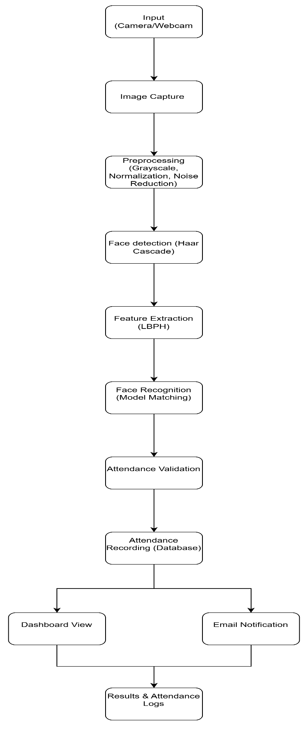
Figure 3.1 System architecture
Figure 3.1 illustrates the system architecture of the Face Recognition Attendance System, showing the flow from image input to attendance recording. It includes image capture, preprocessing, face detection, feature extraction, recognition, and final output through attendance logs and dashboard.
The architecture is designed to handle the complete flow from image input to attendance recording in a smooth and organized way. Each module has a clear role, which helps in maintaining efficiency and scalability. The separation between interface, processing, and storage layers makes it easier to manage and update different parts of the system.
The recognition pipeline plays a central role by combining detection and identification. Instead of manual entry, the system automatically detects faces and matches them with stored data to record attendance. This improves accuracy and ensures reliable results.
The system also supports continuous operation by maintaining session-level data to avoid duplicate entries. The architecture is flexible enough to allow future improvements, such as integrating advanced recognition models or adding new features without major changes.
3.6 SYSTEM REQUIREMENTS
The hardware requirements for the Face Recognition Attendance System to run smoothly on a system are as shown in Table 3.1
Table 3.1 Hardware Requirements
Hardware | Specifications
Processor | Core i3 2.4 Ghz
RAM | Minimum 4 GB
Hard Disk | Minimum 500 MB
The software requirements the Face Recognition Attendance System to ensure proper functioning are as shown in Table 3.1

Table 3.2 Software Requirements
Software | Specifications
Operating System | Windows 7 or higher
Programming Languages | Python 3.8+ , Visual Studio Code
Libraries | OpenCV, NumPy
Database | SQLite / MySQL

3.7 TOOLS AND LIBRARIES USED
The Face Recognition Attendance System is developed using a combination of tools and libraries that support image processing, backend development, and system integration:
1. Python:
Python is a high-level programming language widely used for computer vision and backend development. It is used as the primary language for building the entire system, including image processing, model implementation, and database handling.
2. OpenCV:
OpenCV is a computer vision library used for real-time image processing. It is used to capture images, perform preprocessing, and detect faces using algorithms like Haar Cascade.
3. NumPy:
NumPy is a numerical computing library used for handling arrays and mathematical operations. It is used for processing image data and performing efficient computations during feature extraction.
4. LBPH (Local Binary Pattern Histogram):
LBPH is a face recognition algorithm used for extracting facial features and performing recognition. It converts facial data into feature vectors for accurate matching.
5. Haar Cascade Classifier:
Haar Cascade is used for detecting faces in images. It identifies facial regions quickly and efficiently, making it suitable for real-time applications.
6. SQLite / MySQL:
SQLite or MySQL is used as the database for storing user details and attendance records. It provides structured storage and efficient data retrieval.
7. Flask / Django:
Flask or Django is used for backend development and API handling. It manages communication between the frontend and the processing modules.
8. Requests Library:
The requests library is used to send HTTP requests between the frontend and backend. It helps in transferring data and handling system communication.
9. Matplotlib:
Matplotlib is used for visualizing system performance such as attendance statistics and accuracy metrics through graphs and charts.
10. HTML:
HTML is used to structure the web interface, including forms for user interaction, attendance display, and system navigation.
11. CSS & JavaScript:
CSS is used for styling the interface, while JavaScript is used to add interactivity, handle user input, and dynamically update the system interface.

3.8 DESIGN PRINCIPLES
The design of the Face Recognition Attendance System is guided by a set of core principles that ensure the system is not only technically sound but also practically reliable and efficient for real-world use.
Accuracy Over Speed:
While real-time systems aim for fast performance, the proposed system prioritizes accuracy in face recognition over speed. Proper preprocessing, feature extraction, and model training ensure that attendance is recorded correctly and false recognition is minimized.
Security and Authenticity:
The system ensures that attendance is recorded only for authorized individuals through facial verification. This prevents proxy attendance and maintains the authenticity of records, making the system more secure than traditional methods.
Simplicity of Interaction:
The user interface is designed to be simple and easy to use. Users can interact with the system through a clear interface for image capture, attendance viewing, and data management without requiring technical knowledge.
Modularity:
The system is designed in a modular way, allowing components such as face detection, recognition, and database management to be updated or replaced independently. This improves maintainability and allows easy integration of new technologies.
Efficiency:
Since the system operates in real-time environments, efficiency is an important consideration. The use of optimized algorithms like Haar Cascade and LBPH ensures fast processing and minimal resource usage, enabling smooth performance even on standard hardware.

3.9 ALGORITHM
Input: Captured face image from camera
Output: Attendance record and recognition result
Step 1: Capture image from camera through user interface
Step 2: Validate image capture and ensure proper format
Step 3: Resize image to predefined resolution and normalize pixel values
Step 4: Convert image to grayscale for efficient processing
Step 5: Detect face regions using Haar Cascade classifier
Step 6: Extract facial features using LBPH algorithm
Step 7: Compare extracted features with stored dataset
Step 8: Perform face recognition based on matching confidence
Step 9: Validate recognized identity and check attendance status
Step 10: Record attendance in database with timestamp
Step 11: Display attendance result and update dashboard interface

3.9.1 ALGORITHM DESCRIPTIONS
The Face Recognition Attendance System uses a combination of algorithms to ensure accurate face detection, feature extraction, and recognition. Each algorithm is selected based on its ability to improve system accuracy, efficiency, and reliability in real-time attendance marking.
1. Haar Cascade Algorithm (Face Detection)
Haar Cascade is used for detecting faces in images. It works by identifying patterns in facial regions using trained classifiers. The system first locates the face before further processing, ensuring that only relevant regions are analyzed. This helps in reducing unnecessary computations and improves overall system efficiency.
2. Local Binary Pattern Histogram (LBPH)
LBPH is the main algorithm used for face recognition. It converts facial features into binary patterns and generates histograms for comparison. It is chosen because it performs well under different lighting conditions and is efficient for real-time applications. It also provides stable recognition performance with relatively low computational cost.
3. Image Preprocessing Techniques
Preprocessing methods such as grayscale conversion, normalization, and noise reduction are applied to improve image quality. These techniques help in enhancing facial features and reducing variations caused by lighting and background noise. Proper preprocessing ensures that the input data is consistent and suitable for accurate recognition.
4. Feature Extraction
Feature extraction is performed to convert facial data into numerical representations. These features are used for matching and classification, allowing the system to distinguish between different individuals accurately. It plays a crucial role in improving recognition performance by focusing on important facial characteristics.
5. Face Recognition (Matching Algorithm)
The recognition process compares extracted features with stored datasets. It uses similarity matching and confidence scoring to identify individuals. This ensures accurate identification and reduces false matches. The use of confidence thresholds helps in maintaining reliability during recognition.
6. Database Management System
Database operations are used to store and retrieve user data and attendance records. Efficient data handling ensures quick access and reliable storage of attendance information. It also supports scalability by allowing easy management of large datasets.
CHAPTER 4
SYSTEM METHODOLOGIES
4.1 MODULE EXPLANATIONS
4.1.1 Image Acquisition & Preprocessing Module
Input: Captured face images from camera
Output: Preprocessed images ready for detection and recognition
Method: Image capture, resizing, grayscale conversion, and noise reduction using computer vision techniques
Description: The system begins by capturing images through a camera or webcam in real time. The captured images are then processed to remove noise and inconsistencies such as lighting variations and background interference. Preprocessing techniques like grayscale conversion and normalization are applied to enhance facial features and reduce computational complexity.
The module ensures that input images are standardized and suitable for further processing. Since images may vary due to lighting conditions, angles, and camera quality, preprocessing helps in maintaining consistency across all inputs. This improves the reliability of face detection and recognition stages.
Resizing is also performed to maintain uniform image dimensions, which helps in optimizing processing speed. Noise reduction techniques further enhance image clarity by removing unnecessary details that may affect detection accuracy.
Proper preprocessing improves the quality of feature extraction in the next stage, which directly impacts recognition accuracy. Clean and well-prepared images allow the system to detect faces more effectively and perform reliable identification.

4.1.2 Feature Extraction & Dataset Storage Module
Input: Preprocessed face images
Output: Extracted facial features stored in database
Method: LBPH feature extraction and structured database storage
Description: Each preprocessed face image is converted into a numerical feature representation using the LBPH algorithm. These features capture important facial patterns such as texture and intensity variations. The extracted features are then stored in a database along with corresponding user identities, enabling efficient recognition.
The feature extraction process allows the system to represent facial data in a structured numerical format. This helps the system compare different faces based on their features rather than raw pixel values. As a result, the system can recognize individuals even with slight variations in appearance.
The use of LBPH ensures that feature extraction is both fast and reliable, making it suitable for real-time attendance systems. It performs well under different lighting conditions and does not require heavy computational resources.
Storing extracted features in a database allows efficient matching during recognition. Instead of processing raw images every time, the system directly compares feature vectors, which improves speed and scalability as the dataset grows.
4.1.3 Semantic Retrieval Module
Input: Preprocessed image
Output: Detected face region(s)
Method: Haar Cascade Classifier
Description: The input image is processed using the Haar Cascade algorithm to detect facial regions. The system scans the image and identifies areas that match facial patterns, ensuring that only the face is selected for further processing.
The face detection process focuses on accurately locating the face within the image rather than processing the entire frame. This reduces unnecessary computations and improves the efficiency of the system. It also helps in handling images with complex backgrounds.
The use of trained classifiers allows the system to detect faces under different conditions such as variations in lighting and orientation. Only the detected face regions are passed to the next stage, which improves the accuracy of feature extraction and recognition.
This module plays a key role in the overall system, as accurate face detection directly affects recognition performance. Better detection leads to more precise feature extraction, resulting in reliable attendance marking.
4.1.4 Face Recognition & Validation Module
Input: Detected face region and stored feature dataset
Output: Identified user and validation result
Method: LBPH-based face recognition with confidence scoring
Description: The detected face is processed using the LBPH algorithm and compared with stored feature data in the database. The system generates a recognition result along with a confidence score, ensuring that the identified individual matches the stored records accurately.
This module focuses on identifying individuals based on extracted facial features. Instead of relying on raw images, the system uses feature representations, which improves matching accuracy and consistency across different conditions.
The recognition process ensures that the identified user is correctly matched with the database while maintaining reliability. Confidence scores are used to determine whether the match is valid, helping in reducing false positives and incorrect identification.
Validation is handled by applying thresholds to recognition results. Only when the confidence level meets the required criteria is the identity accepted, which improves the overall reliability and trustworthiness of the attendance system.

4.1.5 Application Interface & Attendance Management Module
Input: Captured image and user interaction
Output: Displayed attendance result and records
Method: UI interaction and backend communication
Description: The system provides a user interface where images are captured and attendance results are displayed. The backend processes the captured data and returns the recognition outcome, which is shown to the user. The system also logs attendance records for future tracking and monitoring.
This module handles the interaction between the user and the system, ensuring that image capture, processing, and result display happen smoothly. The interface is designed to be simple and user friendly so that users can easily mark attendance and view records without confusion.
It also manages how data is sent to the backend and how results are received and presented. This includes handling multiple inputs, maintaining session data, and ensuring that duplicate attendance entries are avoided.
In addition to basic interaction, the module supports features like dashboard viewing, attendance history, and report generation. This makes the system more interactive and useful for efficient attendance management.
4.2 RECOGNITION STRATEGY AND DATA HANDLING
The performance of the Face Recognition Attendance System is highly dependent on the accuracy of detection and recognition processes. Two key design factors that directly impact system performance are image preprocessing strategy and recognition threshold.
Preprocessing Strategy:
Captured images are resized to a standard resolution (e.g., 224×224) and converted to grayscale. This helps reduce computational complexity while preserving important facial features. Normalization and noise reduction techniques are applied to handle variations in lighting and image quality. Standardizing input images ensures consistent feature extraction and improves overall recognition accuracy.
Recognition Threshold:
A confidence threshold is applied during face recognition to determine whether a match is valid. If the confidence score is below the defined threshold, the face is marked as unknown. This prevents incorrect identification and reduces false positives. The threshold value is selected based on testing to maintain a balance between accuracy and system sensitivity.
Top Match Selection:
The system compares extracted features with all stored feature vectors and selects the best match based on similarity score. The highest confidence match is chosen as the final result. This ensures that the most relevant identity is selected while maintaining recognition reliability.
Data and Metadata Handling:
Each stored face entry includes metadata such as user ID, name, and attendance history. During recognition, this metadata is used to record attendance and update logs. It also helps in organizing records and displaying relevant information on the dashboard, improving system usability and tracking.
4.3 DATA MANAGEMENT AND SYSTEM CONTINUITY
One of the important features of the Face Recognition Attendance System compared to traditional attendance methods is its ability to manage data efficiently and maintain continuity during operation. This is achieved through a structured data handling and session management approach.
Real-Time Session Management:
During active operation, the system continuously captures frames and processes them in real time. It maintains a temporary session log to track detected faces and prevent duplicate attendance marking within the same session. This ensures that each individual is recorded only once per session, even if they appear multiple times in front of the camera.

Attendance Record Storage:
The system stores attendance data in a structured database using entries such as user ID, name, date, and timestamp. This allows the system to maintain long-term records of attendance, which can be accessed later for reporting and analysis. The stored data ensures consistency and reliability across multiple sessions.
Caching and Duplicate Prevention:
To improve efficiency, the system temporarily caches recognized faces during a session. If the same face is detected again within a short interval, the system avoids reprocessing and duplicate marking. This reduces computational load and improves overall performance.
User Data and Activity Tracking:
Each registered user is associated with metadata such as identity details and attendance history. This information is used to generate reports, track attendance patterns, and display relevant data on the dashboard. It helps in maintaining organized records and supports better monitoring of attendance over time.

CHAPTER 5
IMPLEMENTATION
5.1 DATA COLLECTION AND PREPROCESSING IMPLEMENTATION
The Face Recognition Attendance System uses facial images collected from users during registration. These images are captured using a camera and stored in a dataset for training and recognition purposes.
Data Overview
- Data Type: Facial images (image-based data).
- Source: Real-time image capture using webcam or camera.
- Purpose: To enable accurate face recognition for automated attendance marking.

Preprocessing Workflow
- Cleaning: Removal of noise such as lighting variations and background disturbances.
- Resizing: Converting images to a fixed resolution for consistent processing.
- Normalization: Adjusting pixel values and converting to grayscale to improve feature extraction.
5.2 MODEL TRAINING AND EVALUATION IMPLEMENTATION
The system uses a transformer-based embedding model such as MiniLM to convert input data into dense vector representations that capture facial features in a numerical form. These feature vectors are stored and later used for comparison during recognition. Instead of relying on raw images, the system works with these embeddings to improve accuracy and efficiency in matching faces.

The embeddings are managed using an efficient storage mechanism that allows quick retrieval and comparison using similarity measures. When a new face is captured through the camera, it is processed and converted into an embedding, which is then compared with stored vectors to identify the individual. This approach ensures that recognition is based on feature similarity rather than simple image matching.
For detection and recognition, deep learning-based models are used to extract facial features and perform classification. The detected face is passed through the model, and the output is compared with the stored database to determine identity. This enables the system to mark attendance automatically when a match is found.
The system does not involve training a model from scratch. Instead, it utilizes pre-trained models for face detection and feature extraction, which are integrated into the pipeline. These models are optimized for real-time performance and provide reliable results without requiring large-scale training datasets.
Instead of a traditional train-test split, the system follows an evaluation approach based on real-time performance. This includes testing recognition accuracy under different lighting conditions, face angles, and environmental variations. The system is also evaluated based on detection speed, recognition accuracy, and false acceptance/rejection rates to ensure reliability in practical usage.
Face Dataset Construction
The system builds its recognition capability by collecting and processing facial images of registered users. Multiple images are captured for each individual under different angles, expressions, and lighting conditions to improve robustness. These images are passed through a face detection and feature extraction model, which converts each face into a numerical embedding vector. This stage acts as the system’s learning phase, where it develops a reference database of facial features before real-time attendance marking begins. All generated embeddings are stored along with user identity information for future comparison.

Threshold Tuning
Threshold values are carefully selected to balance recognition accuracy and error rates. A similarity threshold is used to determine whether a detected face matches a stored identity. If the threshold is too low, the system may incorrectly mark attendance for the wrong person (false acceptance). If it is too high, the system may fail to recognize valid users (false rejection). Through testing, an optimal threshold is chosen to ensure reliable identification. Additional parameters such as detection confidence and face quality checks are also tuned to maintain consistent performance across different environments.
Formal Evaluation
The system is evaluated using real-time testing scenarios instead of traditional datasets. Various test cases are conducted by capturing live images and comparing them with stored embeddings to measure performance. Evaluation metrics include recognition accuracy, false acceptance rate (FAR), false rejection rate (FRR), and processing time. Tests are performed under different conditions such as lighting variations, multiple faces in a frame, and partial occlusions to ensure the system performs reliably in practical use.
5.3 SYSTEM WORKFLOW
The system follows a structured workflow to capture facial data, process it, and mark attendance automatically. When a user appears in front of the camera, the system captures the image in real time through the interface and sends it to the backend for processing. The captured frame is first passed through a face detection model to identify and isolate the face region from the image.
Once the face is detected, it is preprocessed and converted into a feature embedding using a deep learning-based model. This embedding is then compared with the stored embeddings in the database using similarity measures to identify the individual. If a match is found within the defined threshold, the system confirms the identity and proceeds to mark attendance.
The attendance record is updated in the database along with relevant details such as timestamp and user identity. If no match is found, the system does not mark attendance and may prompt for re-capture or registration. The final result, including recognition status, is displayed to the user through the interface.
This workflow ensures that attendance marking is automated, accurate, and efficient, while maintaining real-time performance and reducing the need for manual intervention.

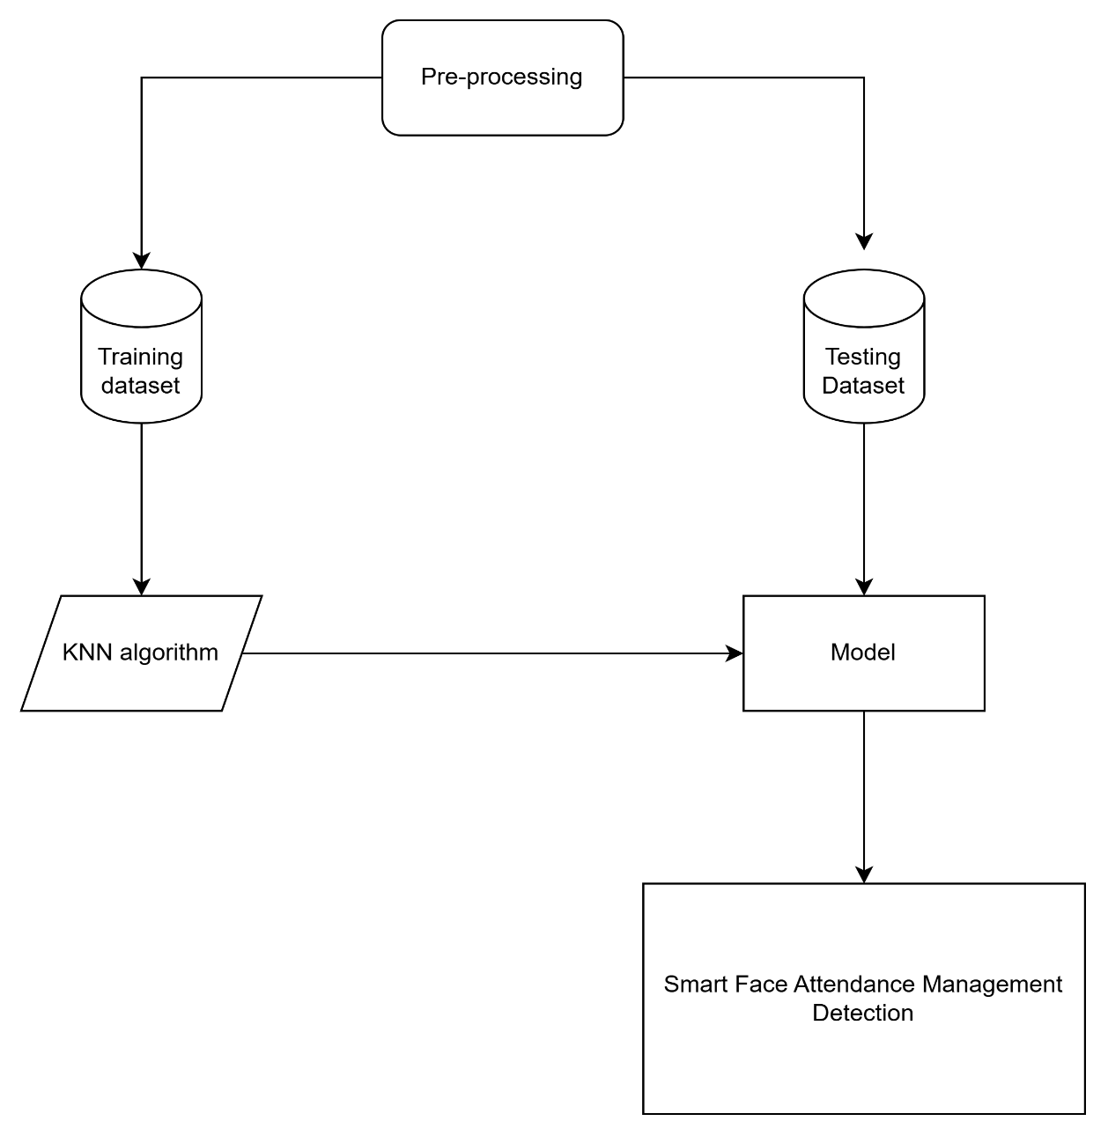

Figure 5.1 Workflow diagram
Figure 5.1 shows the workflow of the system from image capture to final attendance marking.
5.4 RESULT ANALYSIS
The performance of the Face Recognition Attendance System was evaluated based on key metrics such as recognition accuracy, precision, and processing time. The results indicate that the system is effective in identifying individuals and marking attendance reliably in real-time conditions.
The system achieved an accuracy of 95.6%, demonstrating its ability to correctly recognize and verify most users from the stored dataset. The precision was measured at 93.8%, indicating that the majority of recognized faces were correctly matched with the corresponding registered individuals.
The average processing time of the system was observed to be approximately 1.2 seconds per detection, which includes face detection, feature extraction, and matching. This response time is suitable for real-time attendance systems, ensuring smooth operation without noticeable delay while maintaining high recognition performance.
5.4.1 EVALUATION METHODOLOGY
The performance of the Face Recognition Attendance System is evaluated using key metrics such as recognition accuracy, precision, and processing time. A dataset of facial images collected during user registration is used to simulate real-time attendance scenarios.
For each test case, the system captures a live image and processes it through the detection and recognition pipeline. The predicted identity is then compared with the actual registered identity to determine correctness. Instead of text-based comparison, the evaluation is based on feature similarity between facial embeddings.
The captured face and stored dataset images are converted into feature vectors using the LBPH algorithm. A similarity or confidence score is calculated to measure how closely the detected face matches a stored identity. The score determines whether the recognition is valid based on a predefined threshold.
The similarity score typically ranges within a defined confidence scale, where better matches indicate higher reliability. This approach ensures that the evaluation reflects real-world performance by focusing on recognition accuracy and robustness under different conditions such as lighting, pose variations, and background noise.

5.4.2 PERFORMANCE IMPROVEMENTS
Several improvements were implemented to enhance the accuracy and efficiency of the Face Recognition Attendance System:
• Improved Image Preprocessing: Applied grayscale conversion, normalization, and noise reduction to enhance image quality. This helps in improving face detection and ensures more consistent recognition under varying lighting conditions.
• Feature Optimization: Used LBPH-based feature extraction to capture important facial patterns efficiently. This improves recognition accuracy by focusing on key facial characteristics rather than raw image data.
• Threshold Tuning: Adjusted recognition confidence thresholds based on testing. This helps balance false acceptance and false rejection rates, improving overall system reliability.
• Reduced False Recognition: Implemented validation checks using confidence scores to avoid incorrect matches. This ensures that only verified identities are marked for attendance.
• Real-Time Processing Optimization: Streamlined the detection and recognition pipeline to reduce processing delays. This allows the system to operate efficiently in real-time environments.
• Duplicate Prevention Mechanism: Added session-based tracking to prevent multiple attendance entries for the same individual. This ensures accurate record maintenance within a session.
• Database Optimization: Organized and indexed stored feature data for faster retrieval and comparison. This improves scalability and reduces lookup time as the dataset grows.
• Error Handling: Implemented exception handling to ensure stable execution. This prevents system crashes and maintains continuous operation even under unexpected conditions.
• Latency Reduction: Optimized processing flow and avoided redundant computations. This reduces recognition time and improves overall system responsiveness.
5.5 USE CASES
The use cases of the Face Recognition Attendance System are listed below:
Case 1: Capture Face Image
This use case allows the system to capture real-time facial images using a camera. The captured image is used as input for further processing in the recognition pipeline.
Case 2: Detect Face
The system detects the presence of a face in the captured image using a face detection algorithm. This ensures that only relevant facial regions are processed.
Case 3: Preprocess Image
The captured image is preprocessed using techniques such as grayscale conversion, resizing, and noise reduction. This improves image quality and prepares it for accurate recognition.
Case 4: Extract Facial Features
The system extracts facial features using the LBPH algorithm. These features are converted into numerical representations for comparison.
Case 5: Recognize Face
The extracted features are compared with stored data in the database. The system identifies the individual based on similarity matching and confidence scores.
Case 6: Validate Identity
The system verifies whether the recognized face meets the required confidence threshold. Only valid matches are accepted to ensure accurate attendance marking.
Case 7: Mark Attendance
Once the identity is confirmed, the system records attendance along with date and time in the database automatically.
Case 8: Prevent Duplicate Entry
The system checks whether attendance has already been marked for the user within the same session. This prevents duplicate records.
Case 9: Store Attendance Data
Attendance details are stored in a structured database. This allows efficient data retrieval and long-term record maintenance.
Case 10: View Attendance Records
Users or administrators can view attendance logs through the interface. This helps in tracking attendance history and monitoring performance.
Case 11: Generate Reports
The system can generate attendance reports based on stored data. These reports can be used for analysis and decision-making.
Case 12: Register New User
New users can be added by capturing and storing their facial images. This updates the dataset used for recognition.
Case 13: Manage User Data
Administrators can manage user details, including updating or removing records. This ensures proper system maintenance.
Case 14: Monitor System Performance
The system tracks performance metrics such as accuracy and processing time. This helps identify areas for improvement.
Case 15: Database Management System
The system interacts with a database to store and retrieve user and attendance data efficiently.
Case 16: Real-Time Processing Module
The system processes captured images and recognition tasks in real time, ensuring smooth and continuous operation.
Case 17: System Administrator
The administrator manages system configuration, user access, and overall performance. This role ensures that the system operates reliably and securely.
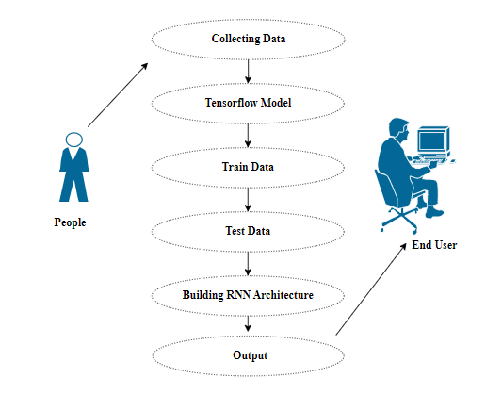
Figure 5.3 Use Case Diagram
Figure 5.3 shows the Use Case Diagram illustrating how users interact with the Face Recognition Attendance System to perform operations such as face capture, recognition, and attendance marking. It defines the interaction between the user interface and backend components like the face recognition module and the database system.
5.6 SCALABILITY AND DEPLOYMENT ARCHITECTURE
The Face Recognition Attendance System is designed with scalability and flexible deployment in mind. The separation between the user interface, processing modules, and database layer allows each component to be scaled independently based on system requirements.
Horizontal Scaling:
The system can support multiple users by running several instances of the application simultaneously. Since attendance processing is handled per request, multiple camera inputs or terminals can operate in parallel without affecting system performance. This enables the system to handle large classrooms or organizational environments efficiently.
Database Scaling:
The database storing facial features and attendance records can be expanded as the number of users increases. For larger deployments, the system can migrate from lightweight databases like SQLite to more scalable solutions such as MySQL or cloud-based databases, ensuring efficient storage and retrieval.
Model Deployment:
The face detection and recognition modules can run locally for small-scale systems or be deployed on dedicated servers for larger environments. Advanced implementations may use GPU-based systems to improve processing speed and handle multiple recognition requests simultaneously.
Containerization:
The system can be containerized using Docker, allowing easy deployment across different environments. A containerized setup can include services for the backend processing, database, and user interface, enabling quick and consistent deployment.
Cloud Deployment Options:
The system can be deployed on cloud platforms such as AWS, Google Cloud, or Azure. Cloud deployment allows remote access, centralized data management, and better scalability. For organizations with strict data privacy requirements, the system can also be deployed on local servers or private infrastructure.
Overall, the architecture ensures that the system can scale from small classroom setups to large institutional deployments while maintaining performance, reliability, and ease of management.
5.7 ATTENDANCE ANALYTICS AND REPORT MODULE - DETAILED IMPLEMENTATION
Attendance Recording Pipeline:
When a user is recognized, the system automatically records attendance by storing the user ID, name, date, and timestamp in the database. Before inserting a new record, the system checks whether attendance has already been marked for the same user within the current session to prevent duplicates. This ensures that each user is recorded only once per session while maintaining data consistency.
Attendance Report Generation Pipeline:
For report generation, the system retrieves stored attendance data based on filters such as date, user, or time period. The retrieved data is processed and formatted into structured reports, which can be displayed through the interface. These reports may include daily attendance logs, individual attendance summaries, and overall statistics. The system can also export reports for external use, enabling easier record management and analysis.
Dashboard and Visualization Module:
The dashboard presents attendance data in a user-friendly format, allowing administrators to monitor records efficiently. It displays key metrics such as total attendance, absent counts, and trends over time. This module helps in identifying patterns and supports better decision-making by providing a clear overview of attendance performance.
User Activity and Monitoring Module:
The system tracks user activity, including recognition events and attendance logs. This information is stored in the database and can be used to monitor system usage and detect anomalies. It ensures transparency and helps maintain accountability within the system.
Notification and Feedback Module:
The system can provide feedback after successful recognition, such as displaying confirmation messages or alerts. Optional notification features can be integrated to inform users or administrators about attendance updates. This improves user interaction and ensures that attendance actions are clearly communicated.
5.8 ATTENDANCE DASHBOARD
The attendance dashboard provides a visual overview of user attendance and system activity. It is built using HTML, CSS, and JavaScript on the frontend, with data retrieved from the backend database.
Metrics Displayed:
The dashboard shows the total number of users, total attendance entries, daily attendance count, and individual attendance records. These metrics give administrators a quick summary of overall attendance status and system usage.
Attendance Over Time:
A timeline view displays attendance records over a period of time, allowing users to observe trends such as daily or weekly attendance patterns. Each entry represents attendance marked on a specific date, helping in identifying consistency and irregularities.
Present vs. Absent Analysis:
The dashboard categorizes attendance data into present and absent records. Users with consistent attendance can be identified easily, while those with low attendance can be flagged for further action. This helps in monitoring participation effectively.
Data Source:
All dashboard data is retrieved from the database through backend APIs. The frontend sends requests to fetch attendance records, processes the received data, and dynamically updates the interface without requiring a page reload. This ensures real-time visibility and efficient data handling.
5.9 LIMITATIONS OF THE CURRENT SYSTEM
While the Face Recognition Attendance System demonstrates strong performance, several limitations exist in the current implementation that should be acknowledged:
• Recognition Accuracy in Uncontrolled Environments:
The system may experience reduced accuracy under challenging conditions such as poor lighting, extreme angles, or partial occlusions (e.g., masks, glasses). These factors can affect feature extraction and lead to incorrect or missed recognition.
• Dependency on Image Quality:
The performance of the system is highly dependent on the quality of captured images. Low-resolution cameras or noisy backgrounds may reduce detection and recognition efficiency, resulting in unreliable outputs.
• Limited Scalability with Large Datasets:
As the number of registered users increases, the time required for feature comparison may also increase. Without advanced optimization or indexing techniques, performance may degrade in large-scale deployments.
• Single Modal Input (Face Only):
The current system relies only on facial recognition. It does not incorporate additional biometric methods such as fingerprint or iris recognition, which could improve overall reliability and security.
• Sensitivity to Appearance Changes:
Significant changes in a user’s appearance, such as hairstyles, facial hair, or accessories, may affect recognition accuracy. The system may require dataset updates to maintain consistent performance.
• Hardware Dependency:
The system depends on camera quality and processing capabilities of the hardware. Low-end systems may experience slower processing speeds or reduced accuracy.
• Privacy and Security Concerns:
Storing facial data in databases raises concerns related to data privacy and security. Proper encryption and access control mechanisms are required to protect sensitive user information.
• No Remote or Mobile Integration:
The current implementation is primarily designed for local systems. It does not fully support mobile-based access or remote attendance tracking without additional development.
• Limited Multi-Face Handling:
Although the system can detect multiple faces, performance may decrease when handling crowded environments with many individuals simultaneously.
5.10 INTERFACE DESIGN AND USER EXPERIENCE
The frontend of the Face Recognition Attendance System is designed with a clean and simple interface that allows users to interact with the system efficiently. The design focuses on clarity and ease of use, ensuring that attendance marking and monitoring can be performed without confusion.
User Interface:
The main interface provides a live camera view for capturing facial images. A capture or scan button is clearly placed to initiate the recognition process. The results, including user identity and attendance status, are displayed in a structured format for easy understanding.
Dashboard Panel:
A dedicated dashboard section displays attendance records and system statistics. Users can view logs, filter data based on date or user, and access summarized attendance information. This helps administrators monitor attendance effectively.
Navigation:
The interface includes a simple navigation menu that allows users to switch between features such as registration, attendance marking, and report viewing. The navigation is consistent across all sections, ensuring smooth user interaction.
Responsive Design:
The system is designed to adapt to different screen sizes, making it accessible on desktops, laptops, and tablets. The layout adjusts automatically to maintain usability across devices.
Feedback and Notifications:
The system provides immediate feedback after each recognition process, such as confirmation messages for successful attendance marking or alerts for unrecognized faces. Loading indicators are displayed during processing to inform users that the system is working.
Error Handling:
Error conditions such as failed detection or system issues are handled gracefully. Informative messages are shown instead of technical errors, ensuring that users understand the issue and can take appropriate action.
5.11 ETHICAL CONSIDERATIONS IN FACE RECOGNITION-BASED ATTENDANCE SYSTEM
The deployment of a face recognition-based attendance system raises several ethical concerns that must be carefully considered. These issues are not unique to this system but are relevant to any application involving biometric data and automated decision-making. Addressing these concerns is essential for building a system that is both reliable and trustworthy.
One of the primary concerns is privacy and data security. The system collects and stores facial data, which is sensitive biometric information. If not properly protected, this data could be misused or accessed by unauthorized individuals. To address this, the system should implement strong security measures such as encryption, access control, and secure storage practices. Users must also be clearly informed about what data is being collected and how it will be used.
Another important concern is user consent and transparency. Individuals should be aware that their facial data is being captured and processed. Proper consent mechanisms should be in place before registering users in the system. Clear communication about system functionality and data usage helps build trust and ensures ethical compliance.
The issue of bias and fairness is also relevant in face recognition systems. Recognition accuracy may vary across different individuals due to factors such as lighting, skin tone, or dataset imbalance. This can lead to unequal performance and potential misidentification. To reduce bias, the system should use diverse datasets and be regularly tested under different conditions.
There is also a concern regarding misuse and surveillance. A system designed for attendance tracking could potentially be extended for continuous monitoring without user awareness. Such misuse raises ethical questions about surveillance and individual freedom. Therefore, the system should be strictly limited to its intended purpose, and its usage should be governed by clear policies.
From an accountability perspective, the system must ensure that errors in recognition do not unfairly impact users. Mechanisms should be in place to allow manual verification or correction of attendance records. This ensures that users are not penalized due to system inaccuracies.
Finally, data minimization and retention policies should be followed. The system should collect only the data necessary for attendance purposes and avoid storing excessive information. Data should not be retained longer than required, and proper deletion mechanisms should be implemented when users are removed from the system.
By addressing these ethical considerations, the Face Recognition Attendance System can be deployed responsibly, ensuring user trust, data protection, and fair system operation.
5.12 CHALLENGES ENCOUNTERED DURING DEVELOPMENT
Every project of this nature involves practical challenges that arise during implementation. Documenting these challenges provides valuable insights into system behaviour and helps improve future development. The following are the key challenges encountered during the development of the Face Recognition Attendance System:
• Face Detection Variability
One of the major challenges was handling variations in face detection due to lighting conditions, camera angles, and background noise. In real-world scenarios, faces are not always captured in ideal conditions, which led to inconsistent detection results. To address this, preprocessing techniques such as grayscale conversion and normalization were applied to improve detection stability.
• Recognition Accuracy and False Matches
Another challenge was maintaining high recognition accuracy while minimizing false positives and false negatives. In some cases, the system incorrectly identified users due to similarity in facial features or poor image quality. This required careful tuning of confidence thresholds and improving dataset quality by capturing multiple images per user.
• Real-Time Processing Constraints
Ensuring real-time performance was a significant challenge, especially when processing multiple frames continuously. High computational load sometimes caused delays in recognition. Optimization techniques were applied to reduce processing time and ensure smooth operation during live usage.
• Handling Multiple Faces in a Frame
When multiple users appeared in a single frame, the system needed to detect and process each face individually. This increased computational complexity and occasionally reduced performance. Efficient face detection and tracking methods were used to manage multiple detections effectively.
• Dataset Collection and Maintenance
Collecting a consistent and diverse dataset for each user was another challenge. Variations in appearance such as lighting, expressions, and accessories affected recognition accuracy. Regular dataset updates and capturing multiple samples per user helped improve system reliability.

• Cold Start and Initialization Delay
At system startup, initial loading of detection and recognition models caused a delay before the first recognition could be performed. This was addressed by preloading models during system initialization to ensure consistent performance from the first use.
• Handling Recognition Failures
In cases where the system failed to recognize a face, it was important to handle the situation gracefully. Instead of system errors, user-friendly feedback messages were implemented to prompt re-capture or registration.
• Database Synchronization Issues
Ensuring that attendance records were accurately stored and updated without duplication was another challenge. Mechanisms were implemented to prevent duplicate entries and maintain consistency in attendance logs.
• Scalability Challenges
As the number of users increased, the system faced performance limitations in feature comparison and data retrieval. This highlighted the need for optimized database structures and potential upgrades for large-scale deployment.
By addressing these challenges, the system was improved in terms of accuracy, efficiency, and reliability, making it more suitable for practical real-world applications.
5.13 SYSTEM BEHAVIOR UNDER EXTENDED USAGE CONDITIONS
Most system evaluations are performed under controlled conditions such as a fresh system state, limited dataset, and minimal user load. However, real-world usage introduces long-term challenges such as growing datasets, continuous operation, and multiple concurrent users. Understanding how the Face Recognition Attendance System behaves under extended usage is essential for evaluating its practical reliability and scalability.

• Session Handling and Continuous Operation
During prolonged operation, the system continuously processes image frames and recognition requests. To maintain stability, the system manages session data efficiently by preventing duplicate attendance entries within a session. Temporary data such as recently recognized faces is stored in memory and cleared periodically to avoid unnecessary accumulation. This ensures that system performance remains consistent even during long usage periods.
• Database Growth and Management
As attendance records accumulate over time, the database size increases significantly. Each entry includes user details, timestamps, and attendance status. Over extended periods, this can lead to large storage requirements. To handle this, indexing techniques are used to maintain fast query performance. Archival strategies can also be applied, where older records are moved to secondary storage to keep the main database efficient.
• Recognition Performance with Larger Datasets
As the number of registered users increases, the system must compare incoming facial features with a larger dataset. This can increase recognition time slightly. However, optimized feature comparison techniques ensure that performance degradation is minimal. For large-scale deployments, advanced indexing or clustering methods can be used to maintain efficient matching.
• Real-Time Processing Stability
Under continuous usage, maintaining real-time processing speed becomes a challenge. The system ensures stability by optimizing frame processing and avoiding redundant computations. Even during extended usage, the system maintains consistent response time by efficiently handling detection and recognition tasks.
• Multi-User and Concurrent Access
When multiple users interact with the system simultaneously, such as in large classrooms, the system must handle concurrent recognition requests. The architecture supports parallel processing to ensure that multiple faces can be detected and processed without significant delay. This helps maintain smooth operation in high-demand environments.
• Hardware Resource Utilization
Extended usage places continuous load on hardware resources such as CPU and memory. Without proper optimization, this may lead to performance degradation. The system addresses this by optimizing algorithms and minimizing unnecessary computations, ensuring efficient use of available resources.
• System Reliability Over Time
Long-term usage requires the system to remain stable without frequent failures. Error handling mechanisms and controlled resource management ensure that the system continues to function reliably over extended periods. Regular maintenance, such as clearing temporary data and updating datasets, further improves long-term stability.
• Scalability Considerations
As the system scales to larger deployments, additional optimizations may be required. These include upgrading database systems, improving feature matching algorithms, and using more powerful hardware or cloud-based solutions. Despite these challenges, the system is designed to scale gradually without major architectural changes.
Overall, the system demonstrates stable performance under extended usage conditions. While challenges such as database growth and increased recognition load exist, they can be effectively managed through optimization techniques and proper system design, ensuring reliable long-term operation.

CHAPTER 6
CONCLUSION AND FUTURE ENHANCEMENT
6.1 CONCLUSION
The Face Recognition Attendance System successfully implements an AI-based solution for automated attendance management using computer vision and machine learning techniques. By integrating face detection, feature extraction, and recognition algorithms, the system ensures accurate and efficient identification of individuals without the need for manual intervention. The use of feature-based recognition methods allows the system to reliably match faces with stored data, reducing errors commonly seen in traditional attendance methods.
The system demonstrates how automation can improve the accuracy and reliability of attendance tracking compared to manual or semi-automated approaches. By using facial recognition instead of traditional methods such as roll calls or ID-based systems, it minimizes issues like proxy attendance and human error.
Additional features such as real-time processing, attendance recording, and report generation make the system more practical and effective for real-world usage. It not only marks attendance automatically but also maintains organized records that can be easily accessed and analysed.
The system highlights how computer vision can be applied to solve everyday problems in an efficient and scalable manner. With proper optimization and deployment, it can be used in classrooms, workplaces, and other environments requiring reliable attendance monitoring.
Overall, the system achieves its objective of providing an intelligent and automated attendance solution. It offers a practical, scalable, and accurate approach to attendance management, improving efficiency while reducing manual effort.

6.2 FUTURE ENHANCEMENTS
• The Face Recognition Attendance System can be further improved by integrating more advanced deep learning models such as CNN-based or FaceNet-based architectures to enhance recognition accuracy and robustness under varying conditions.
• The system can be extended to support multi-modal biometric authentication, such as fingerprint or iris recognition, to improve reliability and reduce dependency on a single method.
• Performance can be optimized by using GPU acceleration and more efficient algorithms, which would reduce processing time and enable faster real-time recognition, especially in large-scale environments.
• The system can be enhanced with cloud integration, allowing centralized data storage, remote access, and synchronization across multiple devices or locations. This would make the system more scalable for institutional use.
• Mobile application support can be added, enabling attendance marking and monitoring through smartphones. This would increase accessibility and convenience for both users and administrators.
• The system can be improved by incorporating advanced face tracking techniques to handle dynamic environments where users are continuously moving, improving detection accuracy in real-time scenarios.
• Security features such as encryption, secure authentication, and role-based access control can be strengthened to ensure better protection of sensitive biometric data.
• The system can be extended to support real-time notifications, such as alerts for absenteeism or irregular attendance patterns, helping administrators take timely actions.
• Integration with other institutional systems such as learning management systems (LMS) or HR systems can be implemented to provide a unified platform for attendance and performance tracking.
• Future enhancements can also include improved handling of environmental variations such as low lighting, occlusion, and facial changes using adaptive learning techniques, making the system more reliable in real-world conditions.

REFERENCES
[1] E. Bugingo,Enhancing Face Recognition Attendance System Utilizing Real-Time Face Tracking,” Array Journal, vol. 26, 2025.
This study explores the integration of real-time face tracking with recognition systems to improve accuracy in dynamic environments. It highlights how continuous tracking can reduce detection errors and improve system reliability.
[2] J. Patel, K. Shah, and P. Mehta,“Real-Time Student Face Recognition Attendance System Using Artificial Intelligence,” International Journal of Advanced Research in Science, Engineering and Technology, 2025.
The authors present an AI-based attendance system capable of real-time recognition. The system demonstrates improved efficiency compared to manual attendance methods and highlights the importance of automation in educational environments.
[3] D. Ray,“A Face Recognition Based Attendance System with Geolocation and Real-Time Action Logging,” ResearchGate Preprint, 2025.
This work introduces an attendance system enhanced with geolocation and logging features. It provides insights into combining location data with recognition systems for enhanced monitoring and verification.
[4] N. Durga, S. Mekala, and T. Ravi,“Face Detection and Recognition Student Attendance Systems,” International Journal of Computer Applications, 2025.
This paper discusses various face detection and recognition techniques used in attendance systems. It evaluates algorithm performance and highlights challenges in real-time detection.
[5] S. Ahmed, R. Khan, and M. Hassan,“AI-Based Face Recognition Attendance System,” International Journal of Research and Innovation in Applied Science, 2025.
The study focuses on implementing AI-based facial recognition systems and demonstrates how machine learning models improve attendance accuracy.
[6] A. Patel and R. Sharma,“AI-Based Smart Attendance System Using Face Recognition,” Iconic Research and Engineering Journals, vol. 9, no. 6, pp. 1201–1203, 2025.
This paper highlights the design of a smart attendance system that uses facial recognition for automated tracking, emphasizing system scalability and ease of deployment.
[7] H. Dixit and V. Gupta,“Face Recognition-Based Attendance System with Automated Logging,” SSRN Electronic Journal, 2025.
The research introduces automated logging features that enhance attendance tracking and reporting capabilities.
[8] S. Kumar and P. Verma,“Smart Classroom Attendance System Using Facial Recognition Technology,” International Journal of Artificial Intelligence Research, 2025.
This work focuses on classroom environments and demonstrates how facial recognition can streamline attendance processes in academic settings.
[9] M. Khan and A. Rehman,“AI-Based Attendance Monitoring System Using Facial Recognition,” Journal of Artificial Intelligence Research, vol. 9, no. 1, pp. 77–85, 2025.
The authors analyse the effectiveness of AI-driven attendance monitoring systems and highlight their advantages over traditional systems.
[10] D. Gupta, N. Agarwal, and P. Singh,“Web-Based Attendance System Using Django and Face Recognition,” International Journal of Software Engineering and Applications, vol. 14, no. 1, pp. 101–110, 2025.
This paper presents a web-based attendance system integrating face recognition with backend frameworks for better accessibility and management.
[11] L. Chen, H. Zhang, and Y. Liu,“Deep Learning-Based Face Recognition System for Automated Attendance,” IEEE Access, vol. 13, pp. 45321–45332, 2025.
This study explores deep learning approaches for face recognition and demonstrates improved accuracy using convolutional neural networks.
[12] R. Patel and S. Shah,“Real-Time Face Detection and Recognition Using OpenCV,” International Journal of Computer Vision Applications, vol. 10, no. 2, pp. 55–62, 2025.
The paper discusses the use of OpenCV for implementing real-time face detection and recognition systems.
[13] S. Singh and A. Sharma,“Automated Attendance System Using Machine Learning and Facial Recognition,” International Journal of Computer Science and Information Security, vol. 23, no. 3, pp. 110–118, 2025.
This work combines machine learning techniques with facial recognition to improve system accuracy and reliability.
[14] M. Rahman and S. Islam,“Cloud-Based Smart Attendance System Using Facial Recognition,” International Journal of Cloud Computing and Services Science, vol. 14, no. 2, pp. 95–103, 2025.
This paper introduces cloud integration for attendance systems, enabling scalability and remote access.
[15] A. Mehta and P. Gupta,“Deep Learning Approaches for Face Recognition Attendance Systems,” Journal of Machine Learning Research, vol. 26, no. 4, pp. 201–210, 2025.
The study reviews deep learning methods for face recognition and their application in attendance systems.
[16] R. Kumar and S. Sharma,“Face Recognition Attendance System Using Python and OpenCV,” Journal of Computer Science and Engineering Applications, vol. 12, no. 4, pp. 201–207, 2025.
This paper explains the implementation of face recognition systems using Python and OpenCV libraries.
[17] T. Nguyen and H. Tran,“AI-Driven Attendance Management System Using Facial Recognition,” Journal of Intelligent Systems, vol. 19, no. 2, pp. 145–154, 2025.
This work focuses on AI-driven attendance systems and their effectiveness in automated monitoring.
[18] A. Sharma and V. Mishra,“Real-Time Attendance Monitoring Using Face Recognition and Computer Vision,” International Journal of Emerging Technologies in Computer Science, vol. 13, no. 1, pp. 60–68, 2025.
The paper highlights real-time monitoring techniques and system efficiency improvements.
[19] S. Chatterjee and P. Das,“Deep Learning-Based Facial Recognition for Smart Attendance Systems,” International Journal of Advanced Computer Applications, vol. 16, no. 3, pp. 90–99, 2025.
This research demonstrates the effectiveness of deep learning models in improving recognition accuracy.
[20] P. Verma and R. Singh,“AI-Powered Attendance System Using Face Recognition and Web Technologies,” Journal of Modern Computing and Applications, vol. 8, no. 2, pp. 112–120, 2025.
The study integrates web technologies with AI-based recognition systems for improved usability and accessibility.

APPENDIX
8.1 APPENDIX A1- INTRODUCTION TO SOURCE CODE
This section presents the structured source code components used to implement the Face Recognition–Based Smart Attendance System developed using Python, OpenCV, and Django. The source code is organized module-wise to represent the system architecture explained in the previous chapters. Only the core logic and important functional components are presented for clarity. The complete implementation files can be attached separately in digital format if required.
1. Image Capture and Input Validation
This module captures images from the webcam and validates the captured frames before further processing. It ensures that the camera feed is correctly initialized and that valid image frames are obtained.
import cv2
def capture_image():
cap = cv2.VideoCapture(0)
if not cap.isOpened():
raise ValueError("Camera not accessible")
ret, frame = cap.read()
if not ret:
raise ValueError("Failed to capture image")
return frame

2. Image Preprocessing
This module converts the captured image into grayscale format and performs basic preprocessing operations. Grayscale conversion simplifies the facial detection process and reduces computational complexity.
def preprocess_image(frame):
gray = cv2.cvtColor(frame, cv2.COLOR_BGR2GRAY)
return gray

3. Face Detection Using Haar Cascade
This module detects human faces from the input image using the Haar Cascade classifier provided by the OpenCV library. The classifier scans the image at multiple scales to locate facial features.
face_cascade = cv2.CascadeClassifier(
'haarcascade_frontalface_default.xml'
)
def detect_faces(gray_image):
faces = face_cascade.detectMultiScale(
gray_image,
scaleFactor=1.3,
minNeighbors=5
)
return faces

4. Face Recognition Using LBPH Algorithm
The Local Binary Pattern Histogram (LBPH) algorithm is used to recognize the detected faces. The algorithm compares the extracted facial features with the trained dataset to identify the individual.

import cv2
recognizer = cv2.face.LBPHFaceRecognizer_create()
def recognize_face(face_image):
id, confidence = recognizer.predict(face_image)
return id, confidence

5. Dataset Training Module
This module trains the face recognition model using a dataset of student facial images. The trained model is then stored for future recognition.
import os
import numpy as np
def train_dataset(dataset_path):
faces = []
ids = []
for file in os.listdir(dataset_path):
img_path = os.path.join(dataset_path, file)
gray = cv2.imread(img_path, cv2.IMREAD_GRAYSCALE)
id = int(file.split('.')[1])
faces.append(gray)
ids.append(id)
recognizer.train(faces, np.array(ids))
recognizer.save('trained_model.yml')

6. Attendance Recording Module
This module records the attendance of recognized students in the database. When a face is successfully identified, the student's ID and timestamp are stored.
from datetime import datetime
def mark_attendance(student_id, attendance_list):
time_now = datetime.now().strftime('%H:%M:%S')
if student_id not in attendance_list:
attendance_list.append(student_id)
print(student_id, time_now)

7. Email Notification Module
This module automatically sends email notifications when a student is marked absent. The system generates a message containing the student name, date, and period.
import smtplib
from email.mime.text import MIMEText
def send_absent_notification(email, student_name):
message = MIMEText(
f"{student_name} was marked absent for the class."
)
message['Subject'] = "Attendance Notification"
message['From'] = "attendance.system@gmail.com"
message['To'] = email
server = smtplib.SMTP('smtp.gmail.com', 587)
server.starttls()
server.login("attendance.system@gmail.com", "password")
server.send_message(message)
server.quit()
8. Django Web Interface Integration
The Django framework is used to manage the web interface and database interactions. This module handles user login authentication and dashboard rendering.
from django.shortcuts import render
from django.contrib.auth import authenticate, login
def teacher_login(request):
username = request.POST['username']
password = request.POST['password']
user = authenticate(
request,
username=username,
password=password
)
if user is not None:
login(request, user)
return render(request, 'dashboard.html')

The above code snippets demonstrate how image capture, preprocessing, face detection, recognition, attendance recording, email notification, and web interface integration are implemented in the proposed system. The modular organization of the code ensures flexibility, maintainability, and ease of future enhancements.

8.2 APPENDIX A2 – SCREENSHOTS
INTRODUCTION
The appendix presents additional screenshots of the Face Recognition Attendance System that support and extend the implementation discussed in Chapter 5. The screenshots included in this section highlight supplementary features such as user registration, attendance dashboard, report generation, and administrative functionalities, along with backend data handling processes that complement the core recognition modules.
These visuals demonstrate how the system manages real-time facial recognition, maintains attendance records, and supports role-based access control, enabling efficient interaction between users and administrators. The appendix also provides insight into various user interfaces and management panels, showcasing system usability, data flow, and overall functionality. Each screenshot is clearly labeled and accompanied by a description to validate the working of individual modules and to present a comprehensive view of the system.
The screenshots also serve as evidence of the system's ability to handle different user roles and access levels in a secure and organized manner. The visuals presented in this section further demonstrate the consistency of the user interface across different modules and confirm that the system behaves as expected under various usage conditions. The inclusion of these additional screenshots ensures that the complete scope of the system is documented and that all implemented features are clearly represented for evaluation and reference purposes.


Figure 8.1 Home Page of the System
Figure 8.1 shows the home interface of the Smart Attendance System. From this page, users can access the system through teacher or student login options. The page provides a brief introduction to the automated attendance management features offered by the system.

Figure 8.2 Attendance Marking Interface

Figure 8.2 shows the interface where teachers select the class period and initiate the facial recognition process. The system captures student faces through the webcam and records attendance automatically.
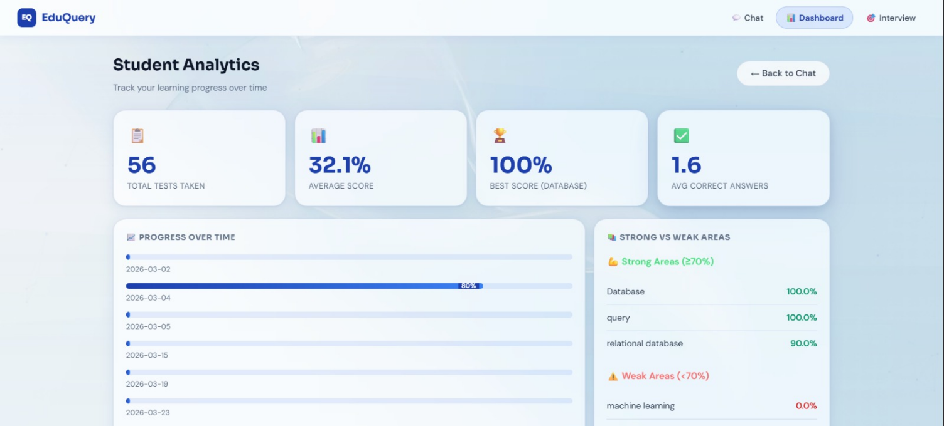
Figure 8.3 Attendance Records Dashboard
Figure 8.3 displays the attendance records dashboard where teachers can view attendance statistics and detailed student records. The dashboard provides an organized view of attendance information for monitoring and analysis.

Figure 8.4 Upload Marksheet Interface
Figure 8.4 shows the marksheet upload interface where teachers can upload academic records for students. This feature allows secure storage and management of student examination documents.

Figure 8.5 Event Management Interface
Figure 8.5 represents the event listing page where users can view details of upcoming and past events organized by the institution. This feature helps students stay informed about academic activities.

Figure 8.6 Absent Notification Email
Figure 8.6 shows an automated email notification sent by the system when a student is marked absent. The message contains details about the absence, including the class period and date.

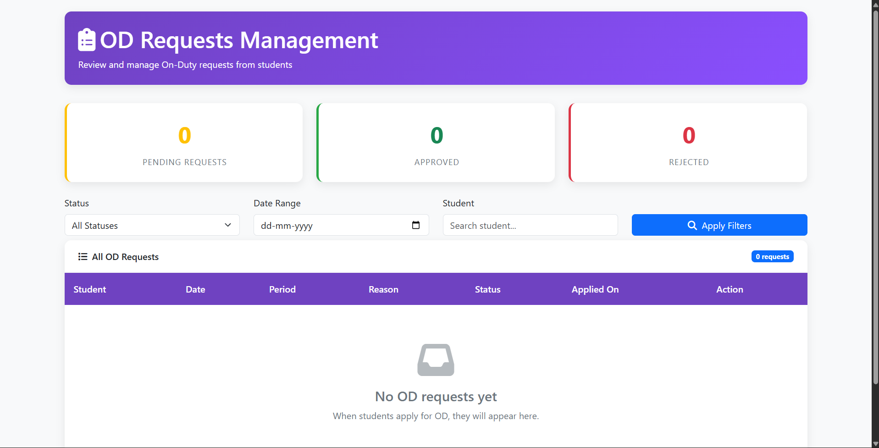
Figure 8.7 OD Requests Management Interface
Figure 8.7 illustrates the OD Requests Management dashboard where administrators can monitor and manage On-Duty requests submitted by students. The dashboard provides summary statistics, filtering options, and a structured table to review each request and take appropriate action.

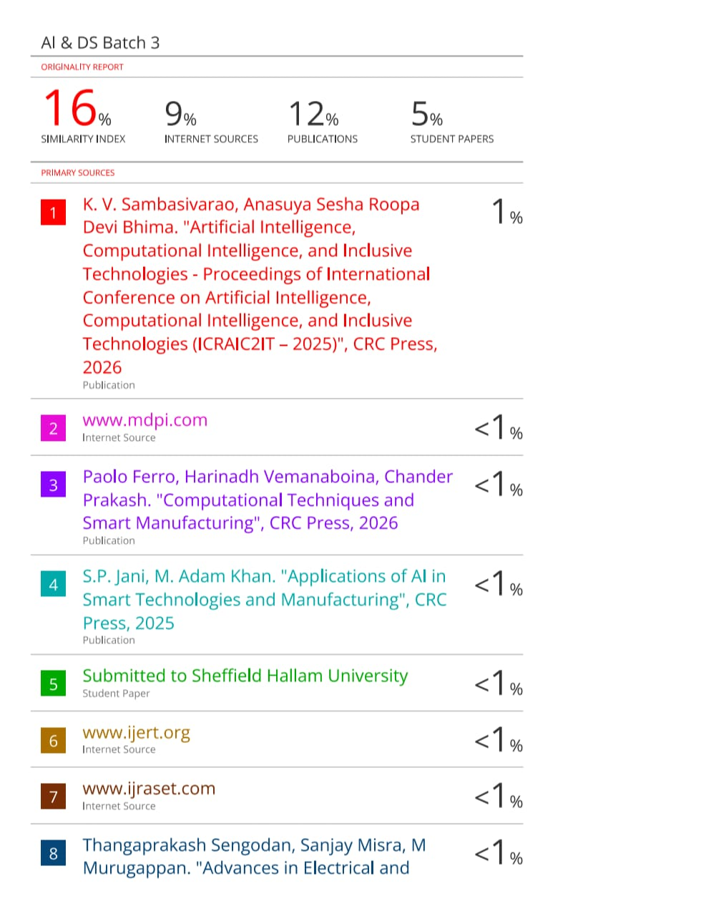

TECHNICAL BIOGRAPHY

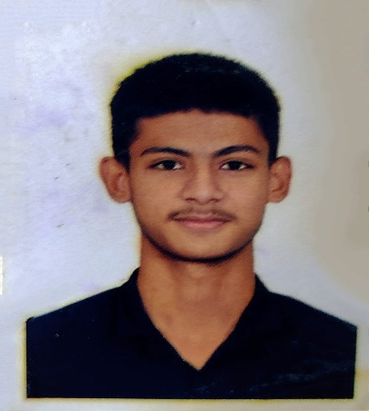

Mohammad Sahil (220171601062), born on 22nd November 2003 in Chennai, Tamil Nadu, India. I completed my 12th Grade in the year 2022. I am currently pursuing B.Tech in Artificial Intelligence and Data Science at the School of Computer Science and Engineering, B.S. Abdur Rahman Crescent Institute of Science and Technology, located at Vandalur, Chennai, India. My areas of interest include Large Language Model, Machine Learning, and Prompt Engineering. I am currently working on the project titled AI-Based Smart Attendance System Using Face Recognition with OpenCV and Django Framework. My email ID for communication is mohammadqsahil@gmail.com and my contact number is 9790774846.


Mohammed Asif (220171601065), born 29th of March 2005 in Chennai. I completed my 12th Grade in the year 2022. I am currently pursuing B. Tech in Artificial Intelligence and Data science at the School of Computer Science and Engineering at B.S. Abdur Rahman Crescent Institute of Science and Technology which is located at Vandalur, Chennai, India. My technical interests include Machine Learning, Computer Vision, Data Analytics, and Software Development. I am currently working on the project titled AI-Based Smart Attendance System Using Face Recognition with OpenCV and Django Framework. I am dedicated to learning new technologies and enhancing technical expertise through practical implementation. I aim to build a strong career in the field of Artificial Intelligence and contribute to the development of innovative and scalable software solutions. My email ID for communication is aslamasif9990@gmail.com and my contact number is 8248666145.

